December 10, 2024

Developer - RPA

RED SKY HEALTH

Appeal Automation BOT

Elevated health

Elevated health

Contents

Project Details 2

Project Overview 2

Input 2

Execution Steps 3

# Project Details

|  |  |
| --- | --- |
| Project Type | Appeal Automation |
| Client Name | Rume Medical Group, Elevated Health |
| Project Manager | Sanjith Nair |
| Developer | Arun Kumar |
| Developed Platform | UiPath |
| Kick-Off Date | 10/7/2024 |
| Live Date | 10/28/2024 |

# Project Overview

A robust UiPath Robotic Process Automation (RPA) solution to automate the repetitive and time-consuming task of checking claim statuses within CollaborateMD. This automation streamlines the revenue cycle management process, reducing manual effort and improving operational efficiency.

**Objectives**

* Automate claim status verification for multiple insurance providers
* Minimize manual data entry and reduce human error
* Accelerate revenue cycle management processes
* Provide real-time tracking and reporting of claim statuses

**Key Features**

* Automated login to practice management suite
* Dynamic claim status retrieval across multiple insurance carriers
* Error handling and logging mechanisms
* Export of claim status results to a designated spreadsheet

# Input

Input data is needed in the spreadsheet format embedded below.



# Execution Steps

**Step 01:** Open to VBA IDE

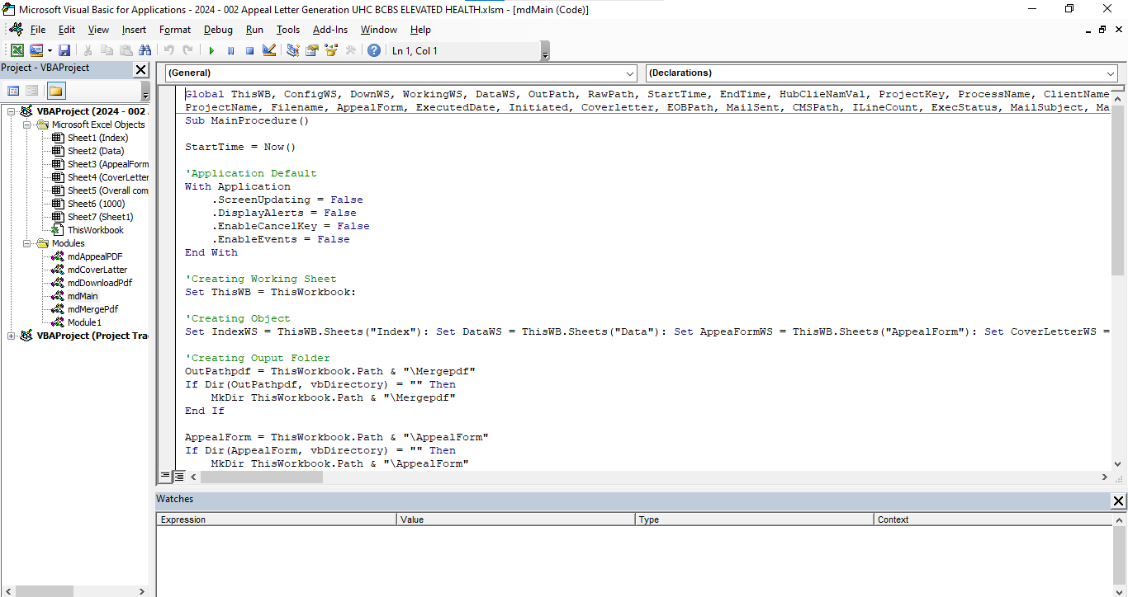

**Step 02:** login to Page Webpage

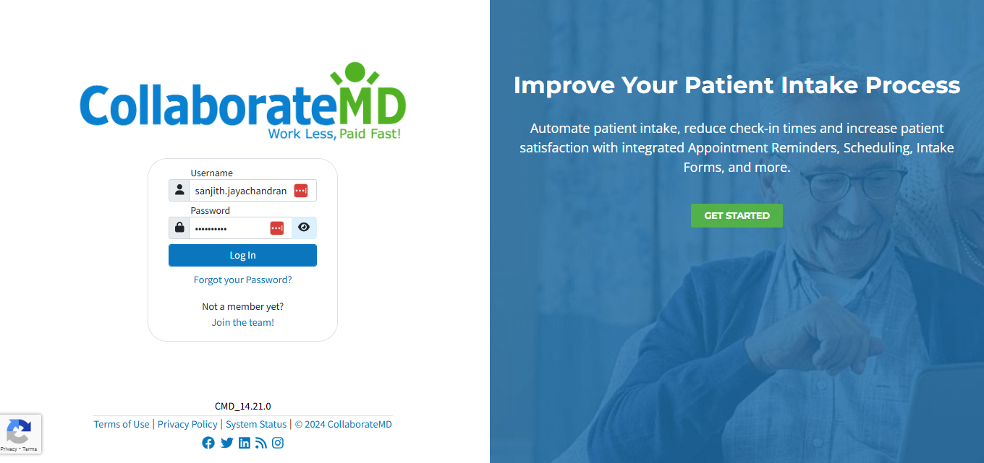

**Step 03:** Select to client location

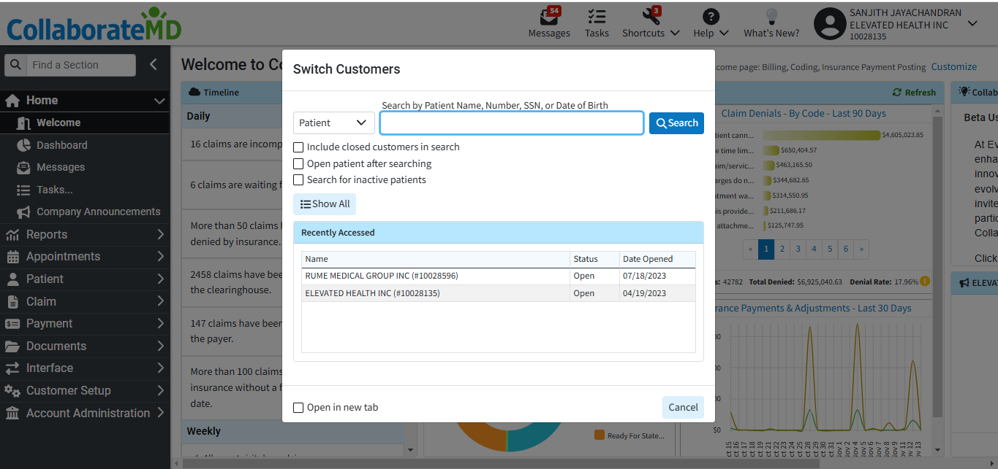

**Step 04:** Click to Claim  
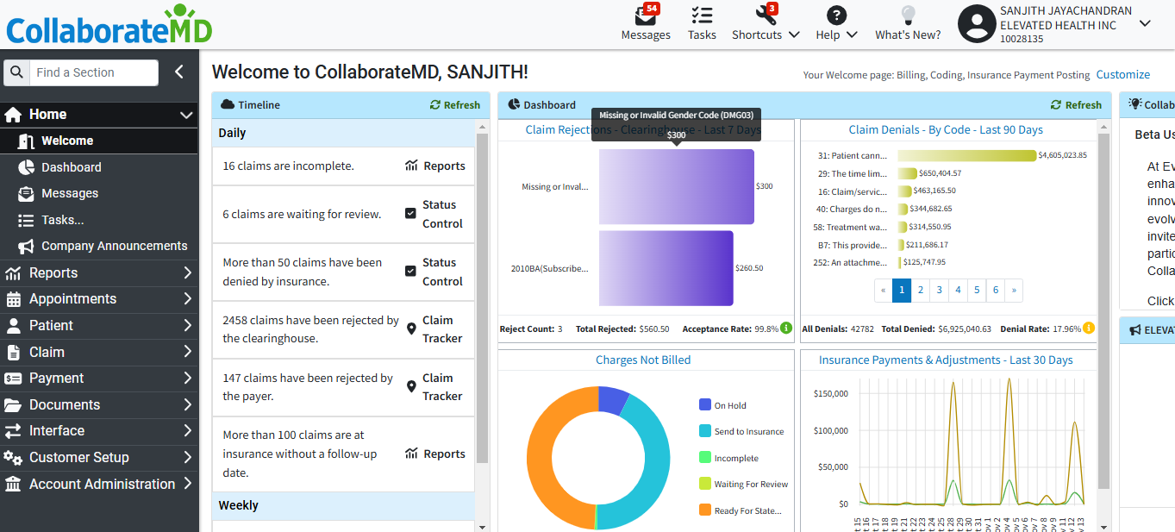

**Step 05:** Search to Claim ID **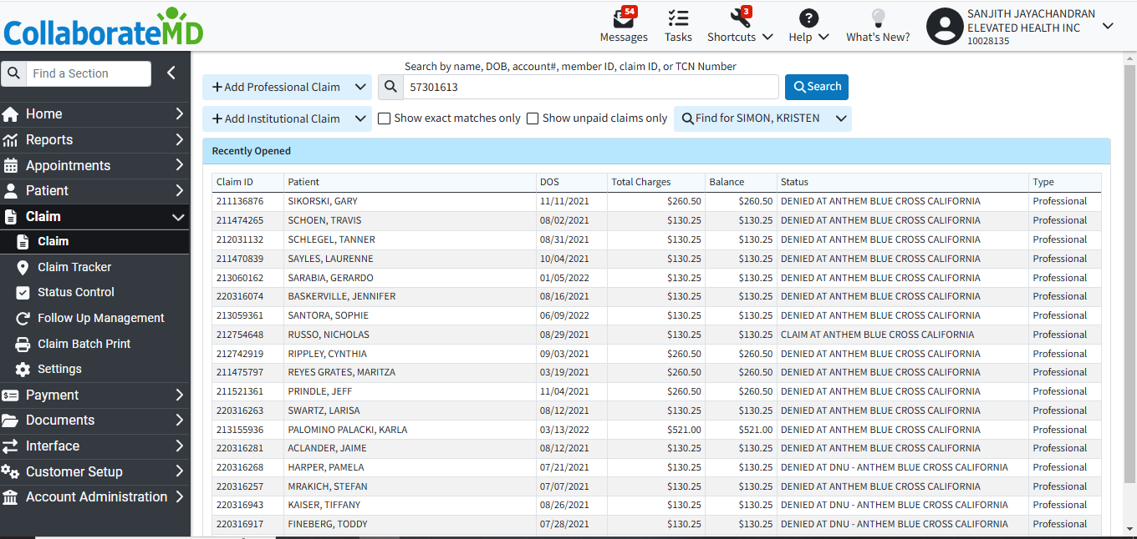  
  
Step 06:** Opento Claim ID Click to Print **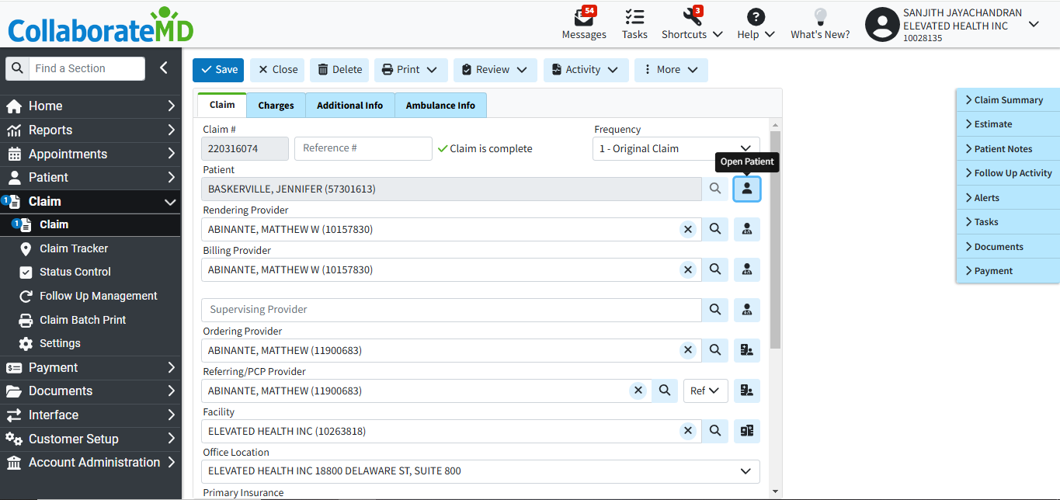  
  
  
  
  
  
  
  
  
  
  
Step 07:** Click to show Preview & EOB click to Print to Download PDF’s **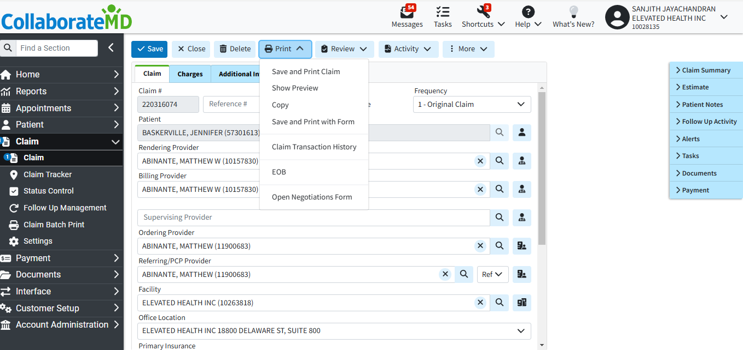  
  
Step 08: Save the pdf File Download folder**

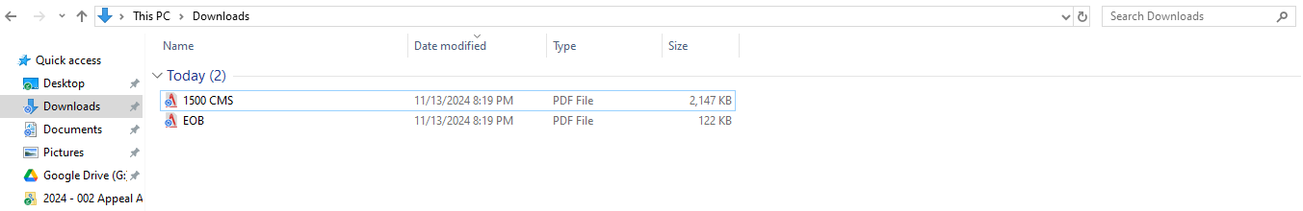  
  
**Step 09:** add the information to the Excel cell and include it in the PDF appeal letter. 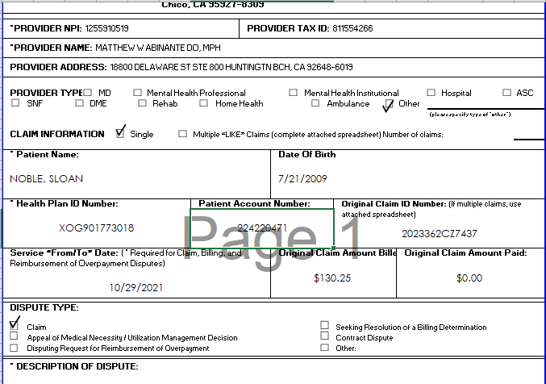

Patient Name   
Date of Birth

Health Plan ID Number

Patient Account Number

Original Claim ID Number

Service Date

**Step 10:** add the information to the Excel cell and include it in the PDF CoverLetter  
 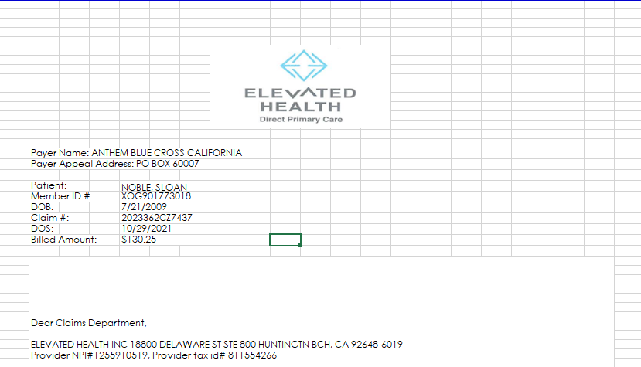

Patient Name   
Member ID

DOB

Claim ID

Billed Amount

Service Date

**Step 11:** add the information to the Excel cell and include it in the PDF CoverLetter 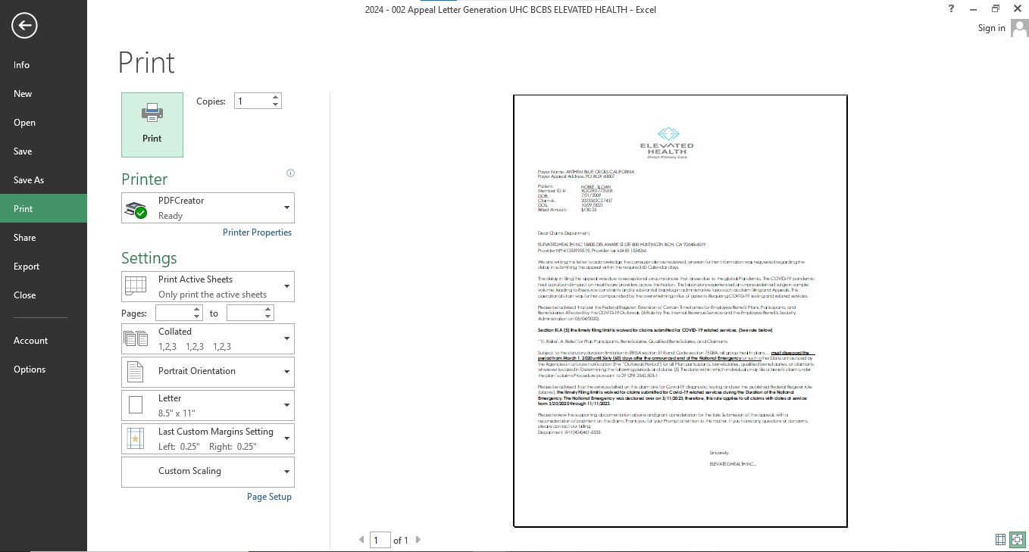

**Step 12:** merge to pdf file’s save to Folder Name & Claim number  
  
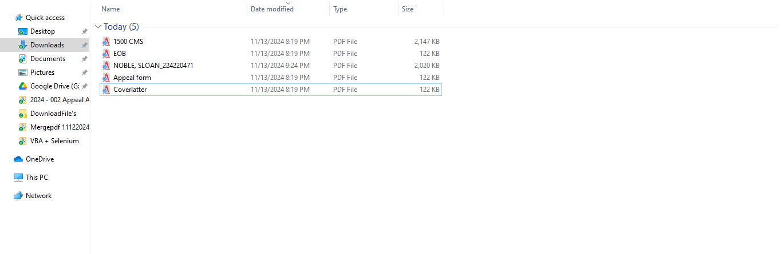  
  
Output

The output would be saved in the bot's same location path.